Library Management System
PROJECT REPORT :

Index / Table of Contents
Introduction
Background (Existing System)
Objectives
Purpose
Scope
Sources & Technologies
System Analysis
Gantt Chart
Existing System & Limitations
Proposed System
Technology Used
System Design
Data Design
Diagrams
Testing
System Coding & Implementation
Deployment
Conclusion
References / Bibliography

1. Introduction
The Library Management System is a web-based application developed to simplify and automate the daily operations of a library. It helps librarians and users manage important tasks such as maintaining book records, managing member information, issuing and returning books, tracking attendance, and sending notifications related to due dates or library updates.
By using this system, manual work is greatly reduced, which minimizes errors and saves time. All library data is stored in a digital format, making it easy to search, update, and manage information. The system also improves communication between the library and its users through automated notifications. Overall, the Library Management System increases efficiency, improves accuracy, and provides better service to both library staff and members.

2. Background
In the existing library system, most of the work is done manually. Records of books, library members, book issuing and returning, and attendance are maintained using registers or spreadsheets. This manual process takes a lot of time and effort, and it is more likely to cause errors such as missing or incorrect entries. Managing and searching records becomes difficult, especially in large libraries with many books and users.
Some libraries also use software such as the Vedyasagar Library Management System. While this software helps in managing library activities, it can be complex and may require more system resources. In comparison, the Library Management System developed by me is lightweight, easy to use, and user-friendly. It is designed with a simple interface that allows librarians and users to perform tasks quickly and efficiently, making daily library operations smoother and more convenient.

3. Objectives
- To automate library operations
- To manage book inventory efficiently
- To maintain accurate member records
- To track borrowing and returning of books
- To generate reports and analytics
- To send automated notifications

Purpose
The purpose of this project is to develop a centralized, user-friendly library management system that helps in managing all library activities in one place. The system aims to improve the efficiency and reliability of library operations by reducing manual work and minimizing errors. It makes it easier to manage books, members, borrowing and returning records, and attendance. Overall, this project is designed to save time, improve accuracy, and provide a better experience for both library staff and users.
5. Scope
The Library Management System is suitable for schools, colleges, and small libraries. It is designed to handle the basic and essential activities of a library. The system supports book management, including adding, updating, searching, and deleting book records. It also manages library members by storing their details and tracking their activity.
In addition, the system provides attendance tracking to monitor library usage and includes admin analytics to help administrators view reports and understand library performance. The system is easy to use and can be accessed through a web browser, making it a practical solution for institutions looking for a simple and efficient library management tool.

6. Sources & Technologies
Frontend
- HTML5
- CSS3
- JavaScript
- Bootstrap
- Flask Templates (Jinja2)

Backend
- Python 3.x
- Flask Framework
- SQLAlchemy ORM
- SQLite Database
- Flask-Mail for notifications

7. System Analysis
a. Problem Definition
- Manual handling of library operations is time-consuming and inefficient.
- Maintaining records in registers or spreadsheets increases the chances of errors.
- Data redundancy occurs due to repeated and unorganized record keeping.
- Searching and updating book or member records is difficult and slow.
- Tracking issued and returned books accurately becomes challenging.
- Managing attendance records manually is unreliable.
- Overall library management becomes difficult as the number of books and users increases.
b. Requirement Specification
Functional Requirements:
- Add, update, delete books
- Member registration and management
- Borrow and return books
- Attendance tracking
- Email notifications
Non-Functional Requirements:
- Security
- Reliability
- Scalability
- Usability

8. Gantt Chart
The project was divided into phases such as requirement analysis, system design, development, testing, and deployment.
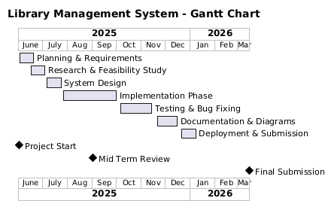

9. Existing System & Limitations
Existing System
• Manual record keeping using paper files or spreadsheets
• No centralized database for data storage
• Data entry is performed by a single user or department
• Records are maintained separately, leading to duplication
• No real-time data access or updates
• Limited use of technology for data processing
Limitations
• High chances of human errors during data entry
• Data inconsistency due to duplicate and unverified records
• Time-consuming operations for searching and updating records
• Lack of data security and access control
• Difficulty in generating accurate reports
• No automated reports or notifications
• Poor scalability as data volume increases
• Risk of data loss due to physical damage or misplacement
• Limited data backup and recovery options

- Feature Scope
  - Core functions (books, members, attendance, notifications, users) are implemented, but there’s no advanced search, analytics, or reporting.
  - No role-based access control beyond basic admin/user distinction.
- Error Handling & Validation
  - Input validation appears minimal; inconsistent checks may lead to data integrity issues.
  - Lack of graceful error messages or logging for operations.
- Performance & Scalability
  - Data stored in CSV or simple models; there’s no optimization for large datasets or pagination.
  - The system isn’t designed for high concurrency—likely only suitable for small-scale or single-user environments.
- Security
  - Password handling and authentication may rely on basic mechanisms (not evident from repo).
  - No evident protection against SQL injection, CSRF, or other web vulnerabilities.
- User Experience
  - The UI is functional but lacks responsive design; usability on mobile devices is uncertain.
  - Bulk operations (import/export) are limited and may not validate imported data effectively.
- Documentation & Maintainability
  - Some docs exist, but API endpoints aren’t formally documented.
  - Code structure could be cleaner; testing coverage is unclear or absent.
- Deployment & Configuration
  - Single run.py/app.py setup suggests manual deployment; lacks containerization or production configuration.
  - No automated build, tests, or CI pipeline.

10. Proposed System
The proposed system is a web-based automated solution designed to overcome the drawbacks of the existing system. It stores all information in a centralized database, ensuring data consistency and integrity. The system provides real-time access to authorized users and supports efficient data management through automation.

Advantages
• Faster and more efficient operations
• Accurate and consistent data storage
• Centralized database management
• Automated notifications and alerts
• Role-based access control for enhanced security
• Easy data retrieval and report generation
• Reduced paperwork and manual effort
• Improved scalability and system performance

Limitations Overcome
• Eliminates manual data entry errors
• Improves data security and access control
• Reduces time consumption for operations
• Prevents data duplication and inconsistency
• Enables automated reporting and notifications
• Ensures proper data backup and recovery

11. Technology Used
Hardware Requirements
- Computer System
- Minimum 4 GB RAM
Software Requirements
- Windows / Linux OS
- Python 3.11+
- Web Browser
Language / Tools
- Python
- Flask
- SQLite
- HTML, CSS

ERD
The ER Diagram represents entities such as Book, Member, User, and AttendanceRecord along with their relationships.
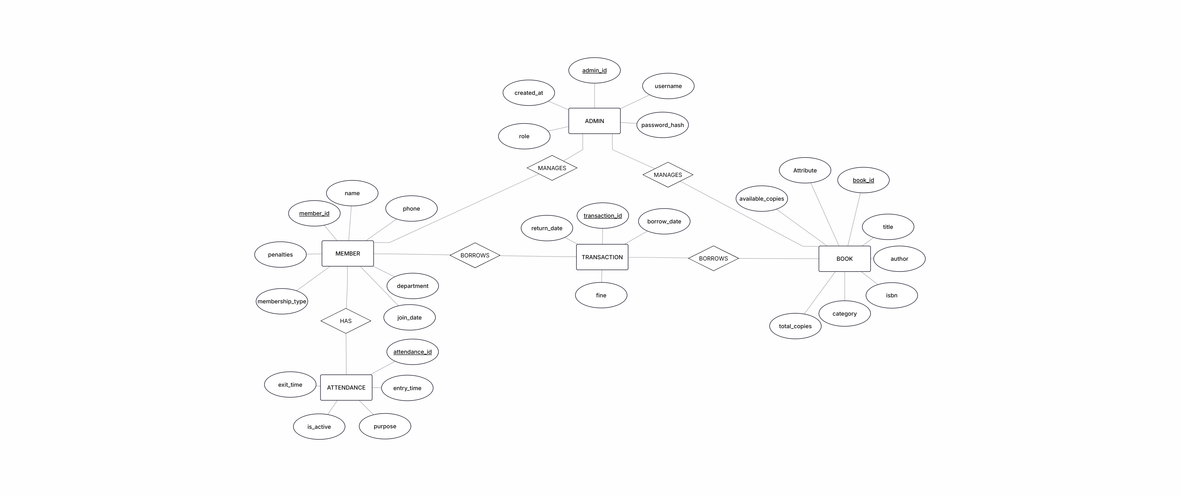

13. Data Design
The system uses a well-structured relational database to store and manage data efficiently. The database is designed to ensure data integrity, consistency, and security. It consists of multiple interconnected tables to support various system functionalities.

Database Tables
• Books Table – Stores details such as book ID, title, author, category, publisher, and availability status
• Members Table – Contains member information including member ID, name, contact details, and membership status
• Users Table – Stores login credentials, user roles, and access permissions
• Attendance Records Table – Maintains entry and exit records of members with date and time
• Transactions Table – Records book issue, return details, fines, and transaction dates

14. Diagrams
Use Case Diagram
The Use Case Diagram illustrates the interaction between users and the system. It shows different actors such as Admin, Librarian, and Member performing operations like managing books, borrowing books, and viewing reports.
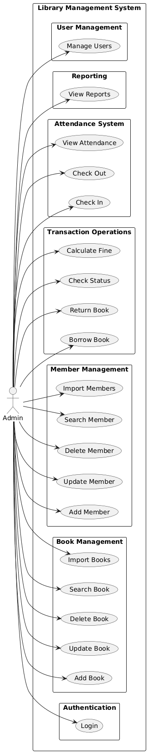
Data Flow Diagram (DFD)
The Data Flow Diagram depicts the flow of data within the system. It shows how data moves between users, processes, and the database during operations like book borrowing, returning, and attendance tracking.
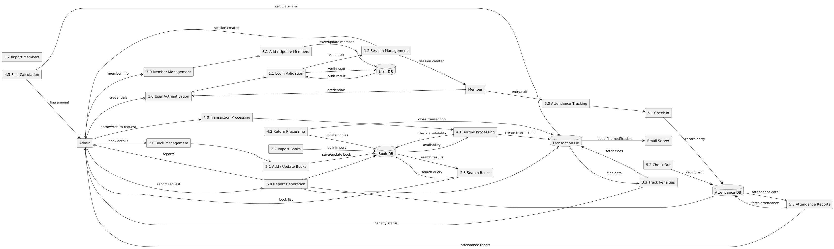

Class Diagram
The Class Diagram represents the object-oriented structure of the system. It defines classes such as Book, Member, User, and AttendanceRecord along with their attributes, methods, and relationships.
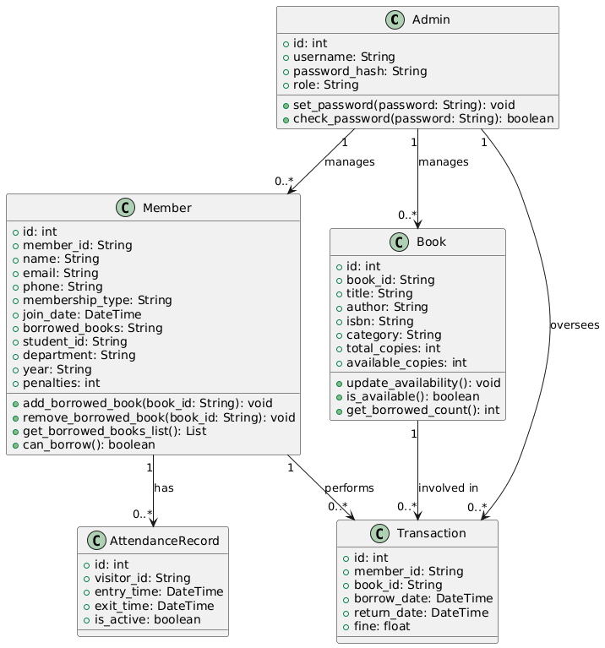

Object Diagram
The Object Diagram shows instances of classes at a particular point in time. It represents real-time objects such as a specific book, member, and borrowing transaction during system execution.
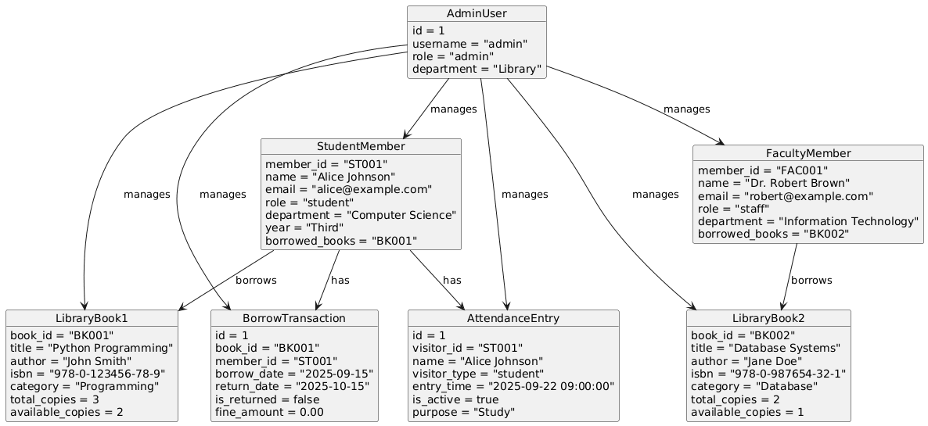

Activity Diagram
The Activity Diagram illustrates the workflow of various processes in the system. It shows step-by-step activities such as user login, book borrowing, return process, and attendance check-in.
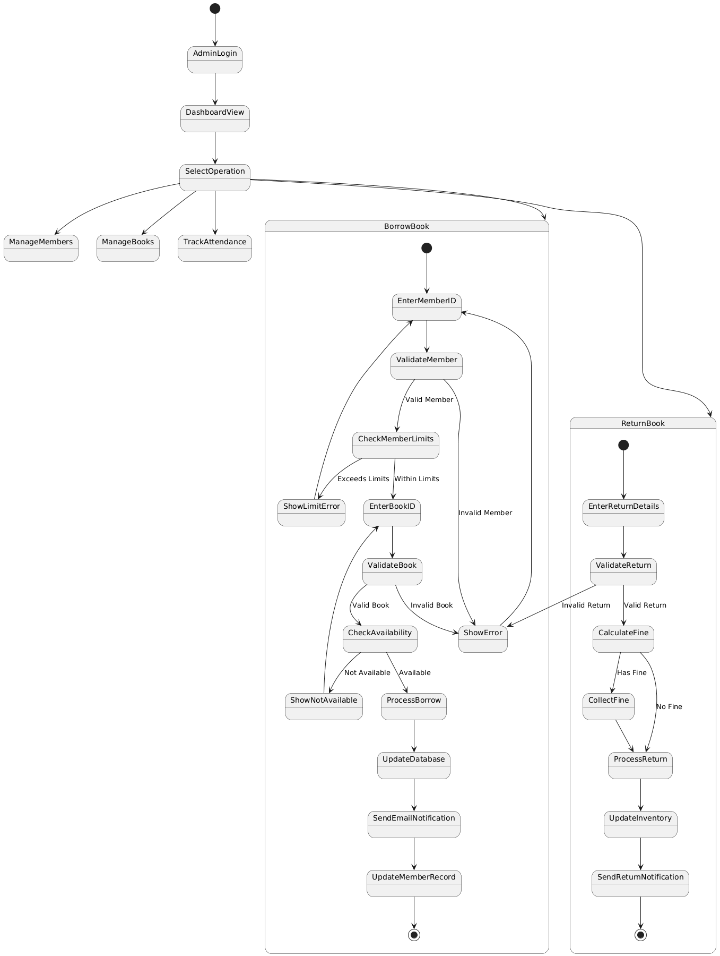
State Diagram
The State Diagram represents different states of an object during its lifecycle. For example, a book can move through states such as Available, Borrowed, Overdue, and Returned.
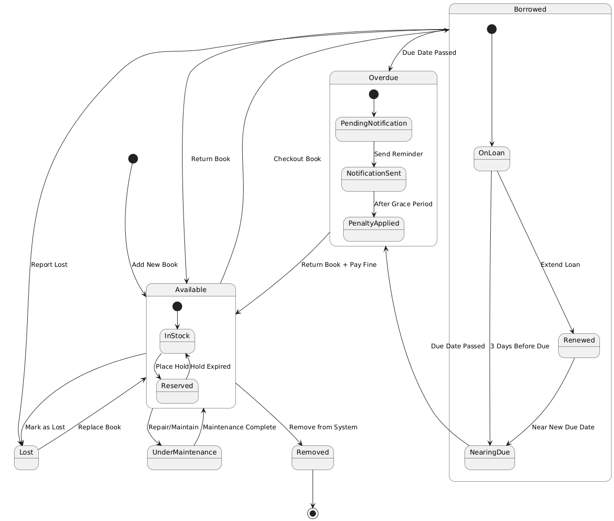

Deployment Diagram
The Deployment Diagram shows the physical architecture of the system. It illustrates how the application is deployed on the server, database, and client machines connected through a network.
